**U01E05 – Php Scripts - III**

Make the following scripts using html and php.

Use array function to solve it. **Array functions:**

<https://www.php.net/manual/en/ref.array.php>

Develop a php script to:

1. Change a text into an array, Split the array into chunks of an specific length. (**array_chunk)**

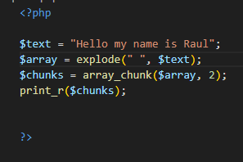

1. Create an array of array with the name of students and their marks in different subjects: maths, languagues, Science. **Array_column**
   1. Create an script to extract the name of the students.

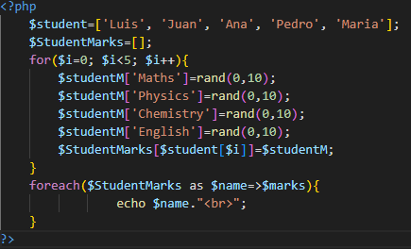

* 1. Create an script to calculate the average of marks of an specific subject.

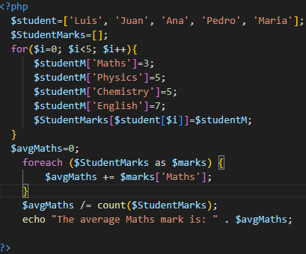

* 1. Create an script to calculate the average of a student marks.

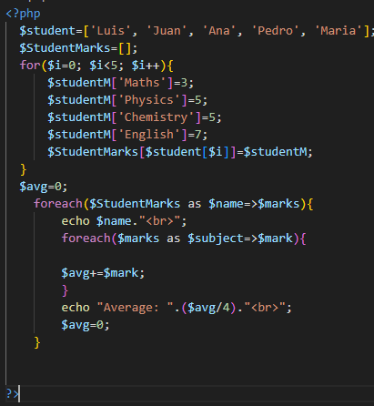

* 1. Create an script to calculate if an student exists and show his marks.

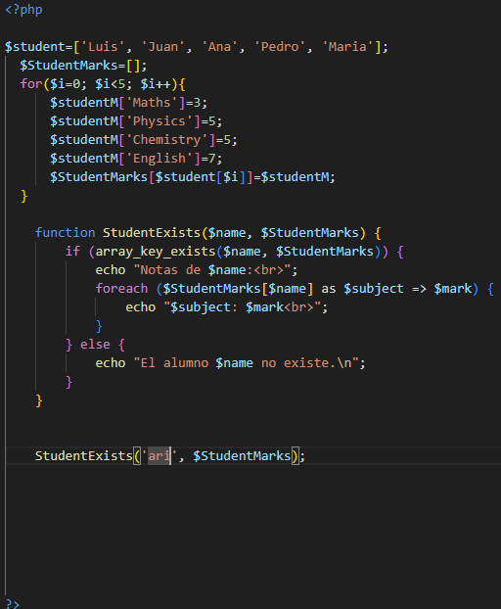

1. Create an array of names and another array of surnames, use **array_combine** to create an associative array of name and surnames.

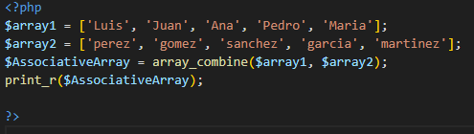

1. Create an array of 3000 random numbers from 1 to 1000. Use the function **array_count_values()** to check the frequency of values and show it.

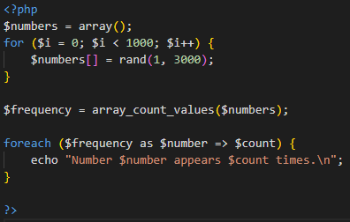

1. Create 2 arrays of 300 random numbers from 1 to 1000. Use **array_diff** and show the result array.

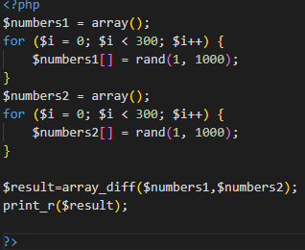

1. Create an array of 30 elements, starting in 5 position, and value DAW. Use. **Array_fill.**

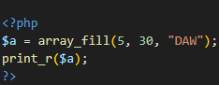

1. You have the text:

“I was born in the year 1632, in the city of York, of a good family, though not of that country, my father being a foreigner of Bremen, who settled first at Hull. He got a good estate by merchandise, and leaving off his trade, lived afterwards at York, from whence he had married my mother, whose relations were named Robinson”

Create an array in which each position in the array is a word. (**explode)**

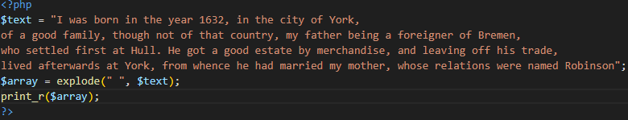

Eliminates repeated words and compacts the array. (**array_unique, compact**)

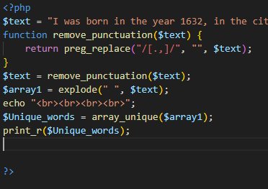

Show the result.

Use **array_flip** and show the result again.

Use **array_merge** and show the result again.

Use **array_intersect_key** and show the result again.

1. Create 2 arrays of 300 random numbers from 1 to 1000. Use **array_intersect** and show the result.
2. Create an arrays of 300 random numbers from 1 to 1000, and pad the array to 1000 elements that are numbers from the highest number of the original array.

Example: A1=(100,50,20,800)

You should pad with numbers from 800.

Use **array_pad**

Use **array_push and array_pop ,** to put the last element at the begining.

Use **array_sort** to order again.

1. You have the text:

“I was born in the year 1632, in the city of York, of a good family, though not of that country, my father being a foreigner of Bremen, who settled first at Hull. He got a good estate by merchandise, and leaving off his trade, lived afterwards at York, from whence he had married my mother, whose relations were named Robinson”

Use **array_replace** to replace “a” for “***”.

Use **array_replace** to replace “the” for “---”

Use **array_reverse** an show the result.

Use **array_search** “e” and show the result.

Use **array_search** “of” and show the result.

Use **array_slice** to show the 5 initial elements.

Use **array_slice** to show elments from 5 position.

Use **array_splice** to have an array with only the position from 5.

Use **array_splice** to have an array with only the 5 last elements.